


UNIVERSITY OF MALAYA IMPACT-ORIENTED INTERDISCIPLINARY

RESEARCH GRANT PROGRAMME (IIRG)
2019-2021

SUB-PROGRAMME
[Incomplete Form will be rejected]
A | TITLE OF PROPOSED RESEARCH/TAJUK PENYELIDIKAN
A(i) | Title of Proposed Research Sub-Programme (Project):  Hydrone: Innovative drone technology for lake conservation management
B | DETAILS OF SUB-PROGRAMME LEADER / MAKLUMAT KETUA SUB-PROGRAM
B(i) | Name of Sub-Programme Leader:  Dr Zati Hakim binti Azizul Hasan  IC / Passport Number:  811109-08-5992
B(ii) | Position (Please tick ( √ )):  Jawatan (Sila tanda ( √ )):  ✓  Professor Assoc. Prof. Senior Lecturer Lecturer  Profesor Prof. Madya Pensyarah Kanan Pensyarah
B(iii) | Faculty /Department/Centre/Unit (Please provide full address):  Department of Artificial Intelligence, Faculty of Computer Science and Information Technology
B(iv) | Office Telephone No.:  (603) 7967 6376  Handphone No.:  017 227 4972
B(v) | E-mail Address:  zati@um.edu.my
B(vi) | Date of First Appointment with this University:  18.09.2014
B(vii) | Type of Service (Please tick ( √ )):  Jenis Perkhidmatan (Sila tanda ( √ )):  Permanent Contract (State contract expiry date): ___17.09.19____  ✓  Tetap Kontrak (Nyatakan tarikh tamat kontrak):
B(viii) | Latest CV & Researchers’ Profile (maximum 1 page each- Please use attached template for the profile and enclose in the Appendix)  CV Terkini & Profile Penyelidik (maksimum 1 muka surat bagi setiap dokumen - Sila gunakan template yang telah disediakan bagi profil penyelidik dan lampirkan di bahagian Apendiks)
C | RESEARCH INFORMATION / MAKLUMAT PENYELIDIKAN
C(i) | Name of Research Institute/Centre/Laboratory/Group :
C(ii) | Location of Research Institute/Centre/Laboratory/Group:  Faculty of Computer Science and Information Technology
C(iii) | Duration of Research Programme (maximum 24 months):  Tempoh masa program penyelidikan (Maksimum 24 bulan):  Tempoh: ____24_____ / ___2____ (month / year)  Duration:
  From: | April | 2019 |  | To: | March | 2021
  Dari: | Bulan/Month | Tahun/Year |  | Hingga: | Bulan/Month | Tahun/Year
C(iv) | Team Members:  ** For the past 5 years and MUST be relevant to the proposed programme.  Kindly attached together the latest CV for all co-researchers (internal & external).
  No. | Name | Faculty/ | H-Index | Citations | No. of Publication** | Contribution to research
  Sub-Programme Leader  Ketua Program | Dr Zati Hakim binti Azizul Hasan | FSKTM | 1 | 4 | 1 | Autonomous robots, multiphysical simulation
  Co-Researcher 1  Penyelidik Bersama 1 | PM Dr Siti Hafizah binti Ab Hamid | FSKTM | 10 | 10.93 (Average) | 5 | Cloud computing
  Co-Researcher 2
  Penyelidik Bersama 2
  Co-Researcher 3
  Penyelidik Bersama 2
D | RESEARCH DETAILS / BUTIRAN PENYELIDIKAN
Di) | Detailed Proposal of Research Sub-Programme :  Maklumat cadangan sub-program penyelidikan secara terperinci:  - Abstract (maximum 150 words) Abstrak (maksimum 150 patah perkataan)  Monitoring water quality of water bodies such as lakes, reservoirs and ponds throughout Malaysia is important to ensure their sustainability and ecosystem functioning and services. Water quality assessment require the collection of water samples for physical, chemical, and bacteriological analysis. Lack of personnel, accessibility of water bodies, and time constraints, especially after natural disasters and emergencies, are some of the challenges of water sampling. To overcome these challenges, the utility of drones for water sampling is now in demand. In this work, we propose a drone with customized sampling attachment to fly over the water, dip a sonde for real-time lake profiling and collects samples for laboratory purposes saves time and improve safety. Our solution enables frequency in data collection at otherwise inaccessible area and multiple sampling at once or immediately after a rainstorm. For testing, we play to deploy at the Tasik Varsity, University of Malaya (UM).  - Graphical Abstract (maximum 1 page-A4)(Please use attached template and enclose in the Appendix)  Appendix A  - Research background including Introduction /Hypothesis /Research Questions and Literature Reviews.  Introduction  Eutrophication of inland water is a prevalent issue in Malaysia, one which threatens the functioning of lake and reservoir ecosystems throughout the country (Sharip & Suratman, 2017). A preliminary study of the status of lake eutrophication reported that more than 60% of the 90 lakes being studied were nutrient rich (NAHRIM, 2009) with a few of them especially the urban lakes experiencing algal blooms, which affect human uses of the water, such as recreation and aesthetic values, while other lakes faced macrophyte infestation problems (Sharip et al., 2014). To address these widespread challenges, improving sampling quantity and quality is necessary for improving lake water quality.  Lake sampling is a fieldwork associated with the collection and transport of water samples. A sampling expedition may include in-situ analysis and/or co-ordination with laboratory for analysis. For example, temperature, dissolved oxygen (DO), conductivity, and pH are measured in-situ as field parameters while other physical, chemical and bacteriological parameters are analyzed in the laboratory (Al-Badaii et al., 2013). At present, a successful sampling expedition include a comprehensive checklist (Ballance and Bartram, 2002) which usually involve a team of water, geographical and safety personnels. In addition, safety of field personnel, suitability of the equipment for analysis, field measurement profiles, temporal and spatial heterogeneity, ecological characteristics, weather conditions, fluvial-sediment transport, and sources of contaminations are other considerations for choosing an appropriate water sampling method. These considerations is required to minimize biases in water profiling.  Biases caused by the water collection process can be curbed with good selection of sampling method and strategic sampling location. Surface water sampling methods include (i) surface dip sample taken at deepest point, (ii) a surface dip sample taken at water edge, (iii) a surface dip sample about 30m from the shore and (v) surface dip sample taken along a short transect out from the shore. For national survey purposes, samples taken from the edge of the lake are the most cost effective. However, for accurate lake profiling, considering multiple sampling stations is the practice to represent the lake’s condition at a given time. Fig. 1 shows the stations selected for water sampling at the Cempaka lake, Bangi (Gasim et al., 2015).  According to the Surface water sampling (2013) guidelines, the physical location of the investigator when collecting a sample may influence bias too. The guidelines reported sampling from accessible location such as steam banks by wading or from low platforms (from small boats or piers), may cause the re-suspension of bottom deposits and bias the sample. If the stream is too deep to wade, or if the sample must be collected from more than one water depth, or if the sample must be collected from an elevated platform (bridge, pier, etc.), supplemental sampling equipment must be used which is cost prohibitive. Fig. 2 shows grab sampling which has been the practice traditionally before sonde technology become available. Fig. 3 shows the data sonde, an electronic multi-parameter probe which auto profiles water properties upon contact with water samples.  In summary, water sampling often involves hauling equipment, boats and people to sites, sometimes hundreds of miles away. To overcome the challenges in performing water collection, methods of sampling by means of airborne mechanism has been in demand. Drones in particular has served different environmental monitoring tasks including thermal infrared imaging of geothermal environments (Nishar et al., 2016), coastal surveying for topographic mapping and measurement (Turner et al., 2016) and marine wild life monitoring (Linchant et al., 2015). Drones are attractive for remote sensing applications due to their capacity carrying sensors, ability to rapidly and remotely travel to locations that are difficul to access and the ability to monitor large areas in short period of time (Beloev, 2016). We are interested to study requirements from the lake sampling community and model an advanced drone solution to improve lake profiling management in this country.  Literature Review  Several significant deployment of drones for water sampling have been recorded and the design of the drone including its sampling mechanism is decribed in Table 1. The aerial works did not specifically followed any guideline for lake water sampling however their considerations for the drone design and sampling mechanism is in accordance to the guideline proposed by Ore et al. (2015) following a discussion with their hydrologist partners:  1. The drone must capture at least three 20 ml water samples at predefined locations within 1 km.  2. The drone must be light and small enough to be carried by a single scientist.  3. The drone samples autonomously once target locations are identified.  4. The drone must be reliable and safe to reduce cost and risk, since these are the primary barriers for adoption.  5. The drone must be cost effective.  6. The drone must not influence water properties.  In terms of the type of drone technology, most of the drones proposed for water sampling in the last 5 years are airborne and only one is water-bound. Generally, multi-copters such as quad-copter (4-rotor), hexa-copter (6-rotor) and octa-copter (8-rotor) are preferred over fixed-wing for their vertical take-off and landing capability similar to a helicopter with fixed pitch propellers and symmetrical design. Other design and developmental considerations in building an appropriate drone for water sampling include:  Frame design and analysis  Most off the shelf drones are aluminium-based, strong and rigid for overall rigidity and strength however fiber glass is opted for the water-bound drone. SolidWorks are preferred for simulation and most of the works simulated the structure properties to get the load distribution, maximum strain, displacement and von Mises stress at given conditions by balancing parameters such as:  a) Material used  b) Total mass (quad/hexa/octa-gonal base + arm)  c) Volume  d) Density  e) Thrust calculation  f) Weight of each motor  g) Length of each arm  h) Edge length of centre hexagon  Dynamic analysis  For acceleration estimation, the drone design must consider:  a) Mass and acceleration  b) Gravity  c) Propeller thrust  d) Drag force  e) Disturbances  Electronic system  To ensure stability, off the shelf electronic boards are sufficient and available open market source are preferred. The main concentration was towards increasing flight time and payload, while consuming the least power. This depends greatly on how much thrust generated as a consequence of the motor-propeller combination. Some electronic aspects for consideration include:  a) Brushless DC motor  b) Propeller (length plays a factor. The longer the lenght, the higher the thrust but more power is consumed)  c) Electronic speed controller (ESC). ESC is an electrical circuit which is used to vary speed of the (BLDC) motor. The speed that is produced depends on the received frequency from controller board. The burst current of each ESC is 30amp with 25gm of weight.  d) Flight controller. The multicopter controller board should include integrated gyroscopic sensors and accelerometer to ensure flight stability.  e) Remote controller for radio control systems (2.4 GHz signal technology and a 6 channels receiver with a range of 100m is usually the base).  f) Battery. To balance weight and power, most design opted for light weighted lithium-ion polymer batteries.  Assembly and system integration  For custom-built drones, most of the components are purchased separately from the open market following considerations of above mentioned specifications and assembled into the prototype. However it is a practice to purchase off the shelf drones (preference for 4 out of 6 works in the last 5 years). The advantages of off-the-shelf drones include:  - Cheaper: It is economically efficient to buy a drone than making it.  - Ready to fly: A purchased drone can be put into flight almost immediately. The Ready-to-Fly quadcopters only require a camera, battery, and propellers attachment to take to the skies.  - Assistance: support for snags and breakage while under warranty, with option to dispatch to the manufacturer for fix or replacements.  - Nil technical know-how required: You need no technical knowledge for purchasing a drone. However, if you construct your own drone technical know-how is a must.  - Better performance: calibration and vibration analysis is perfected prior to sales  Table 1: Comparison table on latest drone designs for lake water sampling  For the drone to be compatible for water sampling activities, the works reviewed proposed differing mechanism to fetch water samples. Interestingly, all of the air-bound drones opted for suspended tethered solution in which a sampling bottle (Terada et al., 2018; Castendyk et al., 2018; Koparan et al., 2018) or several sampling vials (Ore et al., 2015) are attached to it. The difference is in the length of the tether. Some prefers >30m tether length and some prefers <2m length. Regardless of the length, non of the drones touches the surface of the water for sampling and all have issues with the bottle or vials pendulum beneath the drone, disturbing the flight stability. It is also reported that the longer the length of the tether, the harder it is for the operator to maneuvre sampling based on camera input due to the distance to surface of water. In terms of water being let into the bottles or vials, some proposed fabricated mechanism with auto-inlet upon max fill and others proposed a messenger going down the tether to shut the inlet of the bottles or vials. Noted also that most drones perform surface dip sampling except for the ones sampling in pit lakes. None of the works reported sampling along the transact or areas in which the water may experience re-suspension.  In regards to payload, only 2 works consider air-bound drone to have max take-off load >6kg. For this reason, non of the works carry a sonde on-board except for Castendyk et al. (2018) which performs data transfer upon water collection. This is due to the weight of multi-parameter sonde which is usually over 1kg. In terms of performance, the custom-built drones have more freedom in designing and controlling the sampling mechanism, depending on the budget or resources available. If given an option most would prefer to adopt lighter frame to counter payload and power consumption however materials such as carbon fiber are expensive. It is noted that none of the works considered lengthier propeller to improve thrust. All of the works reported efficiency of their drones is highly influenced by environmental factors such as change in wind direction and speed. At times, flight and sampling is delayed or completely abandoned even in moderate wind and light rain.  In summary, developing a drone specific for lake water profiling requires serious considerations on drone specifications as well as the water sampling requirements. For the drone, concentration must be given on the trade-offs between the electromechanical design to push for highest payload and flight time while minimizing battery consumption. On the other hand, implementing efficient sampling mechanism must consider the guidelines used by lake researchers and experts so the solution improves sampling time and is cost effective.  - SMART Objective (s) of the Research/ SMART Objektif Penyelidikan**  S - Specific, significant, stretching  M - Measurable, meaningful, motivational  A - Agreed upon, attainable, achievable, acceptable, action-oriented  R - Realistic, relevant, reasonable, rewarding, results-oriented  T - Time-based, time-bound, timely, tangible, trackable  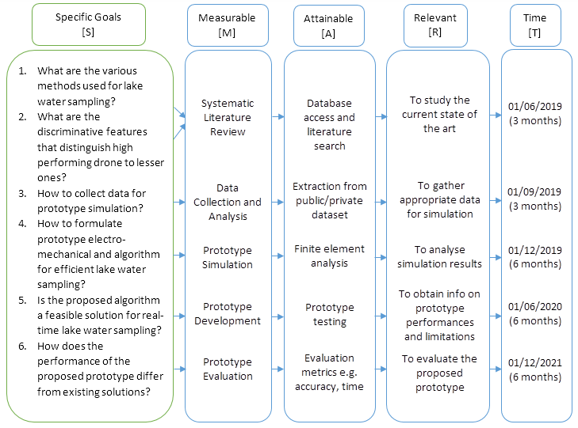  Fig. 6: The SMART method  - Methodology/ Kaedah penyelidikan:  Please state in the form  - Description of Methodology  - Flow Chart of Research Activities ( Please enclose in the Appendix)  - Gantt Chart of Research Activities (Please enclose in the Appendix)  - Milestones and Dates  Fig. 7: Mapping of RQ, RO, methodology and outcome  Fig. 7 shows the mapping of research methodology. We begin with literature search and systematic review to identify discriminators before performing conceptual design of the proposed prototype. We then perform prototype simulation. Once we confirm the desired parameters, we will buy parts for the assembly. System integration is next followed by testing at the Tasik Varsity, UM. We will compare results taken by prototype against hand sampling to see the performance of our prototype. Finally, we will write report and prepare manuscript for journal publication.
  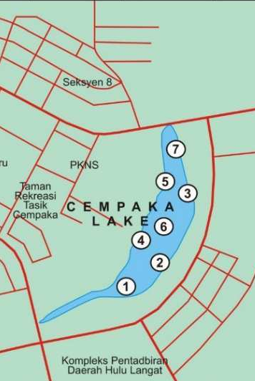  Fig. 1: Location of seven sampling stations in the Cempaka lake (taken from Gasim et al., 2015) | 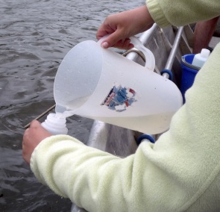  Fig. 2: Grab sampling (taken from Ore et al., 2015)
  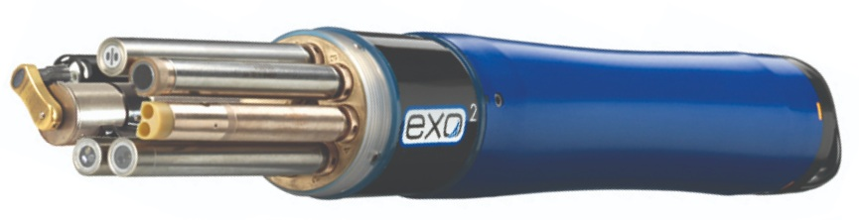
  Fig. 3: Electronic Multi-parameters data sonde by EXO
  Ref & Aim | Drone design | Limitation
  Terada et al. (2018)  Airborne sampling of lake crater | - Off the shelf 6-rotor LAB645 (by Enroutelab, Japan)  - 12kg take-off load  - 40mins flight duration  - 4km return flight route  - 2 x battery 2kg, 350 Wh, 22.5V  - Manual take-off and landing  - Bottle with auto inlet shut when reach max water capacity | - Small amount of water sample (250ml)  - 30m suspended tether  - Rope may snagged on trees  - Operator catches bottle before landing  - Manual water profiling (no sondes on board)  - Maintain 30m above water so to maintain drone communication with operator
  Castendyk et al. (2018)  Airborne sampling of pit lakes | - Off the shelf 6-rotor DJI Matrice600  - 6kg take-off load  - 15mins flight duration  - Bottle requires separate messenger down static tether to shut inlet  - Messenger with sonde for in-situ profiling  - Data transfer available upon landing  - Recorded 80m depth sampling  - USD4,500 price (low-cost) | - 100m suspended tether  - Tether may snagged on trees and powerlines  - Sampling bottle may pendulum below drone making landing the payload difficult  - Weight of payload limits flight duration to <15mins and negates the use of multi-parameter sonde that needs about 2mins to stabilize readings  - Moderate wind and light rain may delay drone operations
  Castendyk et al. (2018)  Water-based sampling of pit lakes | - Custom-built drone-boat (by Uni of Montana)  - 4m length, flat bottomed, drift boat  - Fiber glass body  - Raspberry Pi as central controller  - Uses MS5 data sonde by Hydrolab  - Data sonde comes with reeled data cable of 200m length  - Online data log | - The need to maintain a stable, obstacle-free access road leading to pit lake shoreline  - Requires humans to drive inside the pit and manually deploy the boat  - Only able to study at 200m depth (pit is close to 370m depth)  - USD80,000 price tag (costly to reproduce)
  Koparan et al., (2018)  Airborne sampling of lakes | - Custom-built 6-rotor design  - Autonomous sampling  - Fabricated water capturing mechanism (FWCM) with messenger and floatation attachments  - 18s water sampling duration  - 1.8m suspended tether | - 2.8kg take-off load  - <6mins max flight duration limits to 1.5min flight each testing  - 73 cases, 66% water collection success  - Messenger failure (25 cases), servo motor malfunction (4 cases) and instability (1 case).  - Instable when wind speed >28.97km/h  - Stable when wind speed < 24.14km/h
  Ore et al., (2015)  Airborne sampling of lakes | - Off the shelf 6-rotor design (by Ascending Technology Firefly)  - Fabricated water capturing mechanism  - 1m suspended tether | - 600g take-off load (300g used to load 3 x 20ml sampling vials)  - <20mins max flight duration  - 2km max flight distance  - In-situ analysis upon landing
  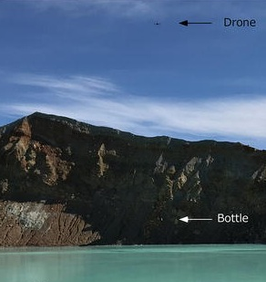  Terada et al. (2018) | 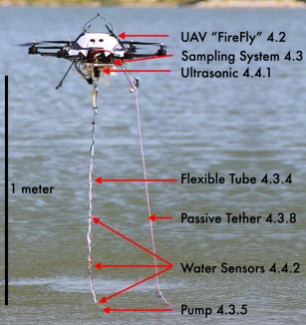  Ore et al. (2015)
  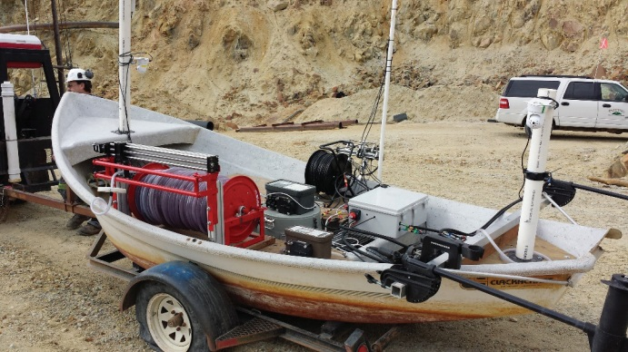  Castendyk et al. (2018) water-based drone | 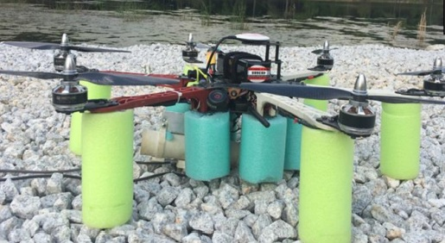  Koparan et al. (2018)
  Fig. 4: Example of drones used for lake profiling, all using suspended tether
  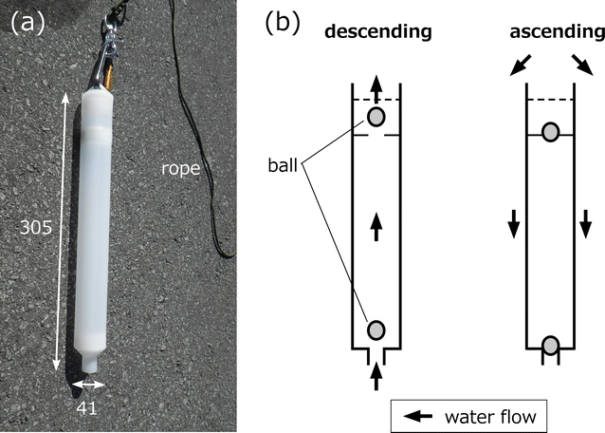  Terada et al. (2018) |  | 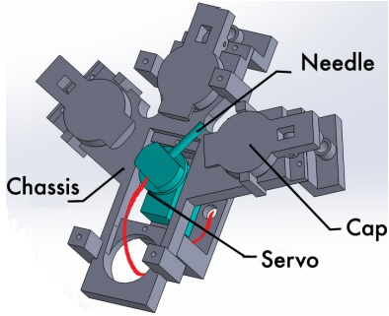  Ore et al. (2015)
  Fig. 5: Examples of auto shut inlet for sampling mechanism
  Research Questions | Research Objectives | Methodology | Outcome
  What are the various methods used for lake water sampling? | To study appropriate discriminators in distinguishing high performing drone for efficient lake water sampling and lesser ones. | - Literature search  - Systematic literature review  - Proof-of-concept | - Findings on the performance of existing approaches  - Novel features to distinguish high performing drones to lesser ones
  What are the discriminative features that distinguish high performing drone to lesser ones?
  How to formulate a balanced electromechanical and algorithm design for efficient lake water sampling? | To simulate drone prototype using finite element method for efficient electromechanical and algorithm design | - Data collection  - Initial simulation design  - Final simulation design  - Test | - Finite element simulation  - Assembly of custom-built prototype
  Is the proposed prototype a feasible solution for a real-time lake water sampling? | To test the performance of the proposed prototype in real-time | - Development and integration of prototype  - Validating and fine-tuning | - New findings on the proposed prototype in terms of time and accuracy
  How does the performance of the proposed prototype differ from existing solutions? | To evaluate and compare the performance of the proposed prototype with existing solutions | - Comparative evaluation | - Results of performance comparison with existing solutions
D | ACCESS TO EQUIPMENT AND MATERIAL /  KEMUDAHAN SEDIA ADA UNTUK KEGUNAAN BAGI PENYELIDIKAN INI
 | Equipment  Peralatan |  | Location  Tempat
 | High performing laptop/workstation  High performing server for cloud storage |  | Faculty of Computer Science and IT
E | BUDGET/BELANJAWAN
Please indicate your estimated budget for this research and details of expenditure
(Please refer to Guideline)

Sila nyatakan anggaran bajet bagi cadangan penyelidikan ini dan berikan butir-butir perbelanjaan dengan lengkap (Sila rujuk Garis Panduan)
 | Budget details  Butiran belanjawan | Amount requested  Jumlah yang dipohon
 | Budget details  Butiran belanjawan | Year 1  Tahun 1  (RM) | Year 2  Tahun 2  (RM) | Total  Jumlah  (RM)
E(i) | Vote 11000 -  Salary and wages  Upah dan Elaun  Untuk Pembantu Penyelidik Siswazah (GRA)  Please specify  Sila nyatakan secara lengkap dengan pecahannya sekali. | 1 GRA  RM2,200 x 12 months  = RM26,400 | 1 GRA  RM2,200 x 12 months  = RM26,400 | RM52,800
E(ii) | Vote 21000 -  Travelling and Transportation/  Perjalanan dan Pengangkutan  Please specify  Sila nyatakan secara lengkap dengan pecahannya sekali.
E(iii) | Vote 24000 -  Rental  Sewaan  Please specify  Sila nyatakan secara lengkap dengan pecahannya sekali
 | Budget details  Butiran belanjawan | Amount requested  Jumlah yang dipohon
 | Budget details  Butiran belanjawan | Year 1  Tahun 1  (RM) | Year 2  Tahun 2  (RM) | Total  Jumlah  (RM)
E(iv) | Vote 27000 -  Research Materials & Supplies  Bekalan dan Bahan Penyelidikan  Please specify  Sila nyatakan secara lengkap dengan pecahannya sekali. | Center frame unit  RM2,300 x 1 unit = RM2,300  Landing gear unit,  RM1,100 x 2 unit = RM2,200  Electronic support unit  RM2,000 x 1 unit = RM2,000  Mounting unit  RM2,100 x 1 unit = RM2,100  Remote controller  RM3,000 x 1 unit = RM3,000  Hex charger and compartment  RM2,000 x 1 unit = RM2,000  Hex arm calibration unit  RM1,400 x 1 unit = RM1,400  Aerial arm  RM1,000 x 6 unit = RM6,000  Battery  RM600 x 6 unit = RM3,600  Zoom gimbal and lens  RM1,200 x 1 unit = RM1,200  Daylight capture unit 1080p 60fps  RM3,000 x 1 unit = RM3,000  Hex folding blades  RM1,800 x 1 unit = RM1,800  Inner foam case  RM600 x 1 unit = RM600  Total = RM31,200 | Sampling attachment  Water proofing material  RM1,000  3D printing material (casing)  RM2,000  Water quality sensor  RM3,000 x 1 unit = RM3,000  Total = RM6,000 | RM37,200
E(v) | Vote 28000 -  Maintenance and Minor Repair Services  Baik pulih kecil dan ubahsuai  Please specify  Sila nyatakan secara lengkap dengan pecahannya sekali. |  | Aerial and sampling mechanism maintenance and repair  RM4,000 | RM4,000
E(vi) | Vote 29000 -  Professional Services  Perkhidmatan Ikhtisas  Please specify  Sila nyatakan secara lengkap dengan pecahannya sekali. | Professional service for sampling attachment and system software/hardware integration  RM3,000 | Professional service for system testing and evaluation  RM3,000 | RM6,000
E(vii) | Vote 35000 -  Accessories and Equipment  Aksesori dan Peralatan  Please specify  Sila nyatakan secara lengkap dengan pecahannya sekali.
TOTAL AMOUNT (RM)  JUMLAH BESAR (RM) |  | RM60,600 | RM37,400 | RM100,000
F | Declaration by Sub-Programme Leader / Akuan Ketua Sub-Program  (Please tick ( √ )):/ (Sila tanda ( √ )):
I hereby declare that:
Saya dengan ini mengaku bahawa:

- All information stated here are accurate, UM has right to reject or to cancel the offer without prior notice if there is any inaccurate information given.
✓
Semua maklumat yang diisi adalah benar, UM berhak menolak permohonan atau membatalkan tawaran pada bila-bila masa sekiranya keterangan yang dikemukakan adalah tidak benar.

- Application of this research is presented for the UM Interdisciplinary Research Programme.
✓
Permohonan projek penyelidikan ini dikemukakan untuk memohon peruntukan di bawah Program Penyelidikan Interdisiplin UM.

- Application of this research is also presented for the other research grant/s
(grant’s name and total amount)
Permohonan projek penyelidikan ini juga dikemukakan untuk memohon peruntukan geran penyelidikan dari (nama geran dan jumlah dana)_________________________________

Date : 28.03.19 Sub-Programme Leader’s Signature :
Tarikh : Tandatangan Ketua Sub-Program :

H | Recommendation by Dean of Research Cluster  Perakuan oleh Dekan Kluster Penyelidikan
Please tick (√ ) /Sila tandakan (√)

Recommendation:
Perakuan:

A. Recommended
Disokong

B. Not Recommended (Please specify reason)
Tidak Disokong (Sila Nyatakan Sebab)

Comments:
Ulasan:

Name: Signature:
Nama: Tandatangan:

Date:
Tarikh:

Note: APPLICATIONS SUBMITTED WILL BE TREATED IN FULL CONFIDENCE. THE DECISION OF THE COMMITTEE PANEL IS FINAL.
Semua permohonan dianggap sulit. Keputusan Jawatankuasa Panel adalah MUKTAMAD.

